|  |
| --- |
| Circle Language Spec: Commands |

## Command Calls in a Command Call in a Diagram

This article demonstrates a situation of command objects.

This article illustrates how command calls in a command call look in a diagram.

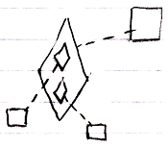

The bigger diamond is a command call, because it is tied to its definition, the larger square, with a dashed line, a class line. The smaller diamonds inside the larger diamonds are command calls inside a command call. The smaller diamonds also point out their definitions, the smaller squares, with a dashed line, a class line.